Project Tender

Project: Willburg SMART Image Identifier

Client: Willburg Outdoor PTY(ltd.), W.A Burger

Team: Ambitious Designs  
Killian Kieck, Stephen Swanepoel, Dian Veldsman, Tim Kirker  
Department of Computer Science, University of Pretoria

Date: 01 / 05 / 2016

The Team

**Killian Ferdinand Noel Kieck**



**Interests**

* Programming.
* Reading.
* Sports.
* Technology.
* Space.
* Gaming.

**Technical Skills**

* Information Technology.
* Coding / Programming (Java, C, C#, C++, JavaScript / jQuery, HTML / css, android).
* Database design and management.
* Software design and development.
* Computer networking.
* Testing.

**Past experience**

* Web design.

**Non-technical strengths**

* Quick Learner.
* Communications skills.
* Initiative.

**Why I want to do the project:**

This is a great opportunity to learn about image detection utilities, effective database management and sorting algorithms, this project offers good experience with challenging aspects. Also a chance to build software which can save the lives of people and animals all over the world.

**Stephen Swanepoel**

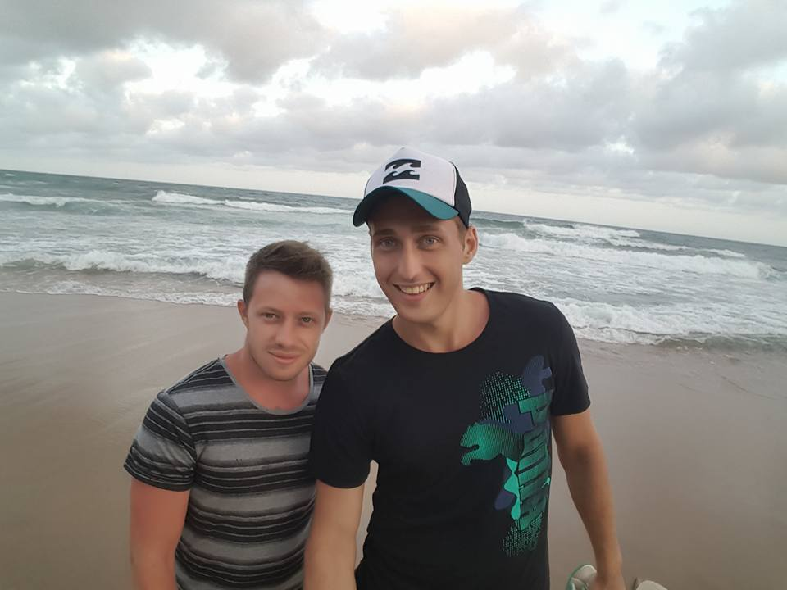

**Interests**

* Programming.
* Nature and wildlife.
* Sports.
* Technology.

**Technical Skills**

* Information Technology.
* Programming (Java, C, C#, C++, JavaScript / jQuery, HTML, CSS).
* Database design and management.
* Software design and development.
* Computer networking.
* Testing.

**Past experience**

* Web design.

**Non-technical strengths**

* Quick Learner.
* Good communications skills.
* Initiative.
* Team player.

**Why I want to do the project:**

From a developers aspect I am interested in this project as I feel it will push me out of my comfort zone and become an interesting learning outcome. I will be exploring new technology which is vital to me as I would like to obtain a strong and diverse skill set regarding software development. Working on an image processing system would assist me in my personal goals to diversify my skill set.

**Dian Johan Veldsman**

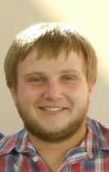

**Interests**

* Programming
* Reading
* Technology
* Gaming
* Watching Movies
* Snooker
* Surfing the Internet

**Technical Skills**

* Information Technology
* Coding / Programming (Java, C, C#, C++, JavaScript / jQuery, HTML / css, android, Python)
* Database design and management
* Software design and development
* Computer networking
* GoF Design Patterns
* Concurrent Systems
* Testing

**Past experience**

* Web design
* Android development

**Non-technical strengths**

* Good coding habits
* Active participation
* Problem solving
* Willingness to learn
* Team player
* Hard working

**Why I want to do the project:**

Crime in South Africa has unfortunately grown exponentially over the past decade. With this project a person will be able to detect if an unknown intruder is lurking about around the house. The reason why I would like to do this project is to be able to use it as an effective early detection device. The project will also allow me develop new and diverse skills, as well as improving on existing skills.

**Tim Kirker**

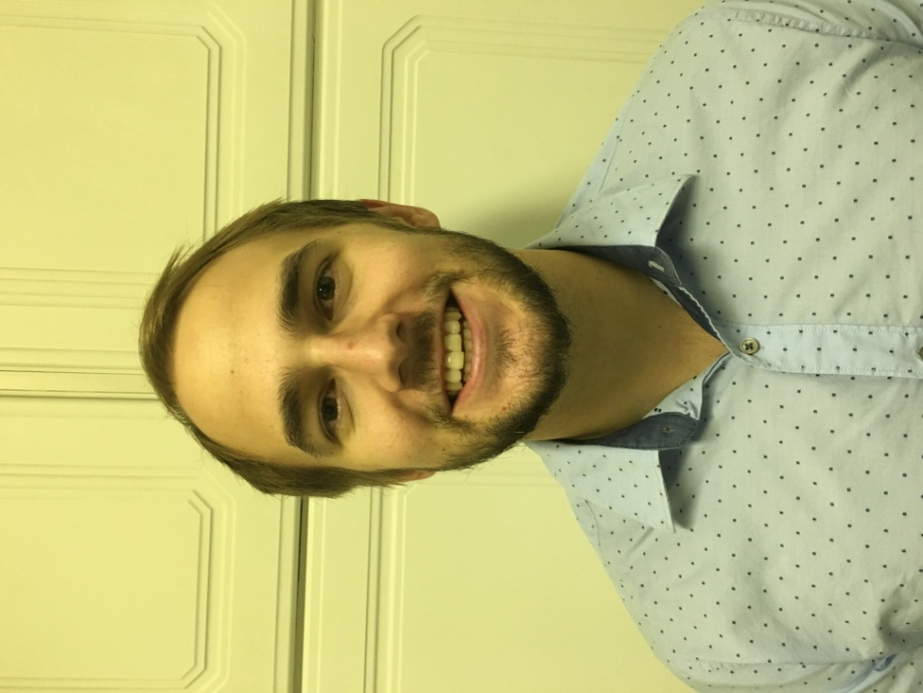

**Interests**

* Sporting activities (both spectating as well as participating).
* Computing whether it be programming or online gaming.
* Music (both listening to it as well as playing musical instruments).
* Reading and keeping up to date with current affairs.

**Technical Skills**

* Programming (Java, C++, JavaScript, Microsoft access, PHP and android development).

**Past experience**

* Free-lance web developer, mathematics tutor and various promotional jobs in the retail sector.

**Non-technical strengths**

* Outgoing
* Good communications skills.
* Hard working.
* Diligent.
* Work well under pressure.

**Why I want to do the project:**

The current epidemic of wildlife poaching and farm attacks is at an all-time high and this project design gives an opportunity to rapidly identify threats and notify those in charge. It would be a privilege to be involved in such a project with potential to save numerous lives, and bring justice to intruders. This project would also act as an opportunity for me to improve my skill set and increase my knowledge in computing.

Project Execution

**Development methodology:**

**How we intend to keep you informed about the status of your project:**

**Initial ideas for solving some of the technical challenges:**

**Technologies we plan on using:**

**What you (the client) will receive at the end of the project:**